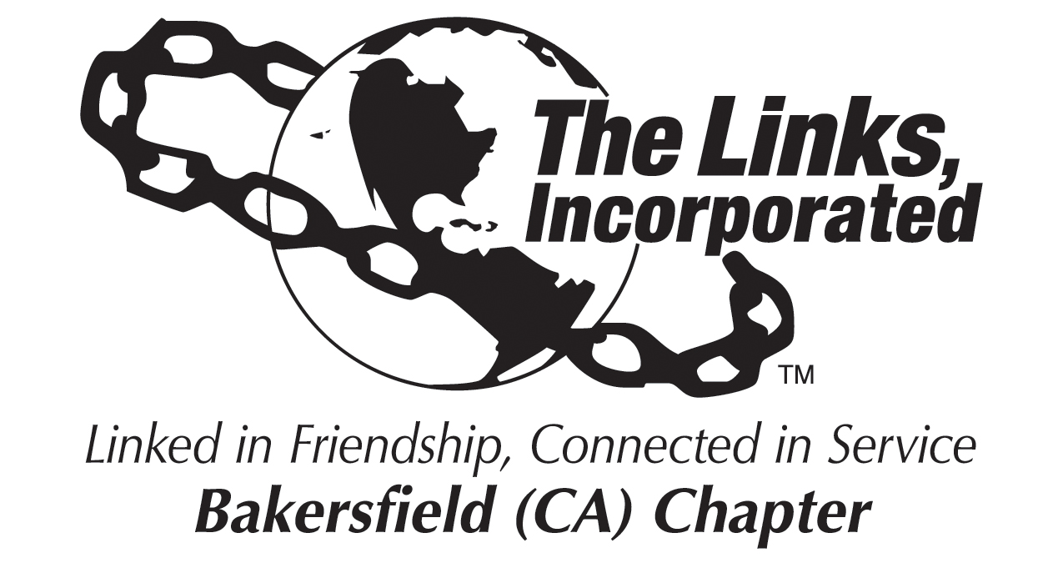

Chapter President, Link Zadie Hurd
Location: ZOOM Platform
Date: September 11, 2021
Meeting Hostess: on hold
Time: 10:00 AM

Call to Order
Pledge
Linkspiration
Roll Call
Approval of Minutes
Correspondence
Officer Reports
- President’s Report
- Vice President – Membership
- Program Coordinator
- Recording Secretary
- Financial Secretary
- Treasurer
Standing Committee Reports
Dates to Remember
Sept. 18th Town Hall – “Ingredients for a Healthy Lifestyle” virtual 9am-11am
Sept. 25^{th,} Links Academy Kick Off
Oct. 2nd, Chapter Meeting

- Audit
Facet Reports
International Trends
Services to Youth
National Trends Service
Health and Human Services
The Arts
Announcements
Adjournment

