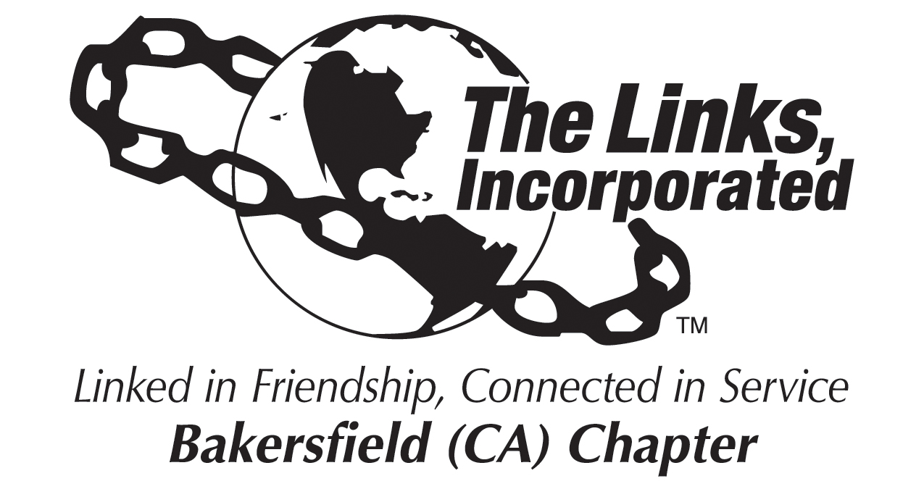

Chapter President, Link Zadie Hurd
Location: ZOOM Platform
Date: October 2, 2021
Meeting Hostess: on hold
Time: 10:00 AM

Call to Order
Pledge & Song
Prayer
Linkspiration
Roll Call
Approval of Minutes
Correspondence
Officer Reports
- President’s Report
- Vice President – Membership
- Program Coordinator
- Recording Secretary
- Financial Secretary
- Treasurer
Dates to Remember
Oct. 9th Links Leadership Academy 9:30am-11:30am
Nov. 6th, Chapter Meeting
Nov. 4th-9th Diamond Jubilee 75yrs
Nov. 9th, Founder’s Day
Nov. 14th WA Founder’s Day Celebration
Nov. Linkspriatation – Link Gredell

Facet Reports
Services to Youth
International Trends
The Arts
National Trends Service
Health and Human Services
Special Committee Report
Black Women Empowering Black Women
Announcements
Adjournment

