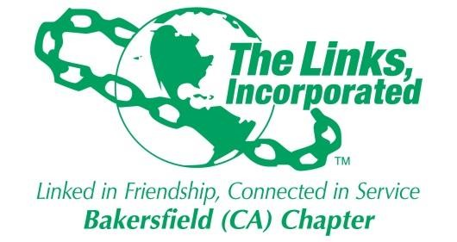

Minutes of Bakersfield Chapter Monthly Meeting

Of
The Links, Incorporated

Zoom Meeting held due to COVID-19

June 12th, 2021
10:00am

Call to Order:
A meeting of the Bakersfield (CA) Chapter of The Links, Incorporated was called to order on June 12th 2021 at 10:01am by Link Zadie Hurd President Bakersfield Chapter. Link Wangari Kihoro, Recording Secretary, present.

Please review the attached attendance spreadsheet for chapter members present. There was a quorum present.

Pledge and Song:
The Chapter members recited the Links Pledge then sang the Links Song.

Prayer

Link Alma Nealy led the Chapter in Prayer .

Linkspiration
Link Tammy Brown read the Linkspiration for this month “ You are Awesome ”.

Minutes
After roll call the minutes for the May Chapter Meeting were reviewed by the members present. Motion was made by Link Rhonda Williams to approve the minutes. The Minutes were approved.

Correspondence:
Link Zadie Hurd read the correspondence.
Motion was made by Link Tomeka Powell that that the Bakersfield Chapter participate in the Juneteeth NAACP event on June 19th 2021 at Yokuts Park. Motion was approved.

Officer Reports:
- President’s Report: Link Zadie Hurd.
- 45th Western Area Conference- Footprints to the future, A whole new world was held virtually June 2nd to June 5th 2021.
1765 members registered, 93 Alumni and 460 were first time attendees of conference.
- 46th Western Area Conference will be held in Los Angeles in 2023 - Rebirth, Reconnection and Renewal.
- 47th Western Area Conference will be in Dallas Texas.
- Link Odella Johnson was appointed by The Western Area to BWEBW Membership.

Vice President-Membership: Link Tammy Brown.
Link Tammy presented her report.
- 18 members from The Bakersfield Chapter attended the Virtual Western Area Conference
- The Drive by welcome is June 12th 2021 (today) to welcome the new Chapter members.
- The Chapter Retreat will be held virtually August 7th 2021.

- Vice President-Programs: Link Odella Johnson.
- Link Odella presented her report.

- Secretary Report: Link Wangari Kihoro.
No report presented.

- Financial Secretary’s Report: Link Michele Burris.
Link Michele presented her report.

- Treasurer’s Report: Link Tomeka Powell
Link Tomeka presented her report.
Motion was made by Link Rhonda Williams that the Chapter approve the new fillable PDF voucher forms presented by Link Tomeka Powell. Motion was approved.

Committees:
-International Trends & Services:
No report presented.
-Services To Youth: Link Essie Davis & Link Ida Randall Richardson
The culminating event was held June 6th 2021. It was a great year for the Academy, and there
Was great representation from the Chapter.
-Health and Human Services: Link Debra Strong
June is Mental health awareness month.
Bakersfield College is offering the Johnson & Johnson (one shot) and the Moderna
Covid 19 Vaccines.
-National Trends and Services:
No report presented.

-Strategic Planning: Link Michele Burris.
No report presented.
-BWEBW:
No report presented.
-Technology:
No report presented.
-The Arts:
No report presented.
-The Nominating Committee:
No report presented.
-Mental Awareness:
No report presented.
-Southern California/Nevada Cluster:
No report presented.
-HBCU:
No report presented.
-Western Area Report: President Link Zadie Hurd
Link Zadie presented her report.

New Business:
No new business.

Announcements:

-Link Zadie Hurd: Great grandson born May 31st 2021.

-Link Debra Strong: Heir-O-Link Whitney Strong got a new job in Nashville Tennessee. She will be working as a National Certified school Psychologist.

-Link Tomeka Powell: Heir-O-Link Savannah Frye was in the Bakersfield paper talking about her Lollipop Business.

-Link Mary Tomlin: Connecting Link Harold Tomlin lost his younger sister Eleanor Escalera. Her Funeral is on June 18th 2021 at Greenlawn SW Mortuary.

-Link Olivia Washington: Heir-O-Link Chantel Washington MD is now certified as an OBGYN.

-Link Allison Perkins Thomas: Thank you for all the calls and cards after the passing of her beloved mother. She would like to thank the Chapter for their kindness to her family.

-Link Addonica Stanley: Will be leaving BCSD to join NCEE (National Center on Education & Economy) as their National facilitator.

-Link Janell Burton: Link Janelle Burton will be the new Dean at West High School.

-Link Christi Dugas Cramer: Heir-O-Link Emily Cramer a 9th grader is working on her AA. Link Christi will be working as an Adjunct Professor at National University.

Adjournment:
After closing remarks by President Link Zadie Hurd, the meeting was adjourned at 11:42am.

Date
Submitted by Link Wangari Kihoro
Bakersfield Chapter
Recording Secretary

