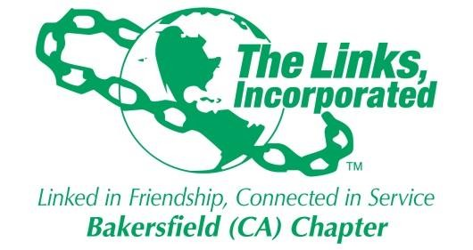

Minutes of Bakersfield Chapter Monthly Meeting

Of
The Links, Incorporated

Zoom Meeting held due to COVID-19

September 11th , 2021
10:00am

Call to Order:
A meeting of the Bakersfield (CA) Chapter of The Links, Incorporated was called to order on September 11th 2021 at 10:06 am by Link Tammy Brown for Link Zadie Hurd President Bakersfield Chapter absent. Link Wangari Kihoro, Recording Secretary, present.
The Chapter observed 20 seconds of silence in remembrance of September 11th 2001 twentieth year anniversary.

Please review the attached attendance spreadsheet for chapter members present. There was a quorum present.

Pledge and Song:
The Chapter members recited the Links Pledge then sang the Links Song.

Prayer

Link Alma Nealy led the Chapter in Prayer “Let go and let God”.

Linkspiration
Link Tammy Brown read the Linkspiration for this month “We are Sisters”.

Minutes
After roll call the minutes for the June Chapter Meeting were reviewed by the members present. Motion was made by Link Mary Tomlin to approve the minutes. The Minutes were approved.

Correspondence:
Link Denise Norris read the correspondence.

Officer Reports:
- President’s Report: Link Tammy Brown for Link Zadie Hurd absent.
- The Links are Celebrating 75 years this year.
Motion was made by Jennifer Floyd to spend $175 to do a video and portrait greeting to participate in the Diamond Jubilee. Motion was approved.
- Link meetings are to remain virtual until December 31st 2021.
- Founders day celebration for The Western Area is on November 14th.

- Vice President-Membership: Link Tammy Brown.
Link Tammy presented her report.
- The Links will continue to focus on the ten core values.
- The Code of Ethics forms are due September 30th . Members are required to do the webinar. It is mandatory. The next two webinars are on September 27th and October 19th.
- Track it Forward- continue to put in service hours.
- September birthdays: Alma Nealy 3rd, Mary Tomlin 7th, Tammy Brown 8th,
Zadie Hurd 21st and Karen Nealy 29th.

- Vice President-Programs: Link Odella Johnson.
- Link Odella presented her report.
- Western Area is having the first BWEBW webinar on September 21st

- Secretary Report: Link Wangari Kihoro.
No report presented.
-Members were reminded to update their information on the National website.

- Financial Secretary’s Report: Link Michele Burris.
Link Michele presented her report.

- Treasurer’s Report: Link Tomeka Powell
Link Tomeka presented her report.
-The bonding and taxes for the Chapter are done. They are due on September 15th.
-Motion was made by Link Jennifer Floyd that the Chapter purchase a new Chapter photo by using money from the Branding budget, with up to $500 limit. Motion was approved.

Committees:

Audit Report: Link Karen Nealy
Link Nealy presented the Audit report.
-International Trends & Services:
No report presented.
-Services To Youth: Link Essie Davis & Link Ida Randall Richardson
The STY is busy getting ready for the Academy. They are working on the QR codes for the
Letter and registration forms for the Academy.
-Health and Human Services: Link Debra Strong & Link Allison Perkins Thomas
-September is Aging health month.
-September 25th is the 26th Annual walk for Healthy living Walk-A-Thon. The walk can be
Virtual or outside.
-National will have “Black health Matters” as a theme this year
-National Trends and Services:
No report presented.
-Strategic Planning:
No report presented.
-BWEBW:
No report presented.
-Technology: Link Addonica Stanley
Link Addonica updated the chapter on the likes and followers on Facebook.
-The Arts:
No report presented.
-The Nominating Committee:
No report presented.
-Mental Awareness:
No report presented.
-Southern California/Nevada Cluster:
No report presented.
-HBCU:
No report presented.
-Western Area Report:
No report presented.

New Business:
No new business.

Announcements:

-Link Denise Norris reminded every member to vote On September 14th on “The Recall Vote”.

And, The NAACP is having a Get out The Vote on September 12^{th.}

Adjournment:
After closing remarks by Link Tammy Brown, the meeting was adjourned at 11:55am.

Date
Submitted by Link Wangari Kihoro
Bakersfield Chapter
Recording Secretary

